Project Development Phase
Model Performance Test
Date | 1 October 2026
Team ID
Project Name | Import Data using Transform Maps (Spreadsheet)
Maximum Marks | 10 Marks
Model Performance Testing:
Project team shall fill the following information in model performance testing template.
S.No. | Parameter | Values | Screenshot
1. | Metrics | Import Metrics (Transform History):  First import (new and changed data) - Total rows - 4, Inserted - 2, Updated - 2, Skipped - 0  Re-import of the same sheet - Total rows - 4, Inserted - 0, Updated - 0, Ignored - 4  Result Summary:  Rows processed correctly - 4 of 4 in both runs; no duplicate records created | 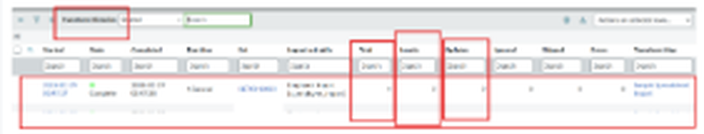  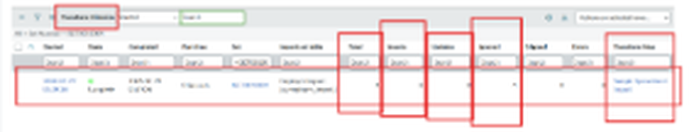
2. | Tune the Model | Coalesce Tuning - Coalesce set to true on the Employee ID field map of Sample Spreadsheet Import  Validation Method - Transform History counts (Total, Inserted, Updated, Ignored) checked after each run, and the Employee Test list reviewed to confirm the inserted and updated rows | 